CCNA LAB MANUAL
Version 4.0

Lab Report
Labs 18, 19 & 20
Cisco Switch IOS | Spanning Tree Protocol | Switch Configuration & VLAN
Step-by-Step Solutions with CLI Screenshots
Submitted By:
Student Name: _______________________________
Roll No.: _______________________________
Date: _______________________________

LAB 18: CISCO SWITCH IOS
This lab covers the fundamental IOS commands used to configure and manage Cisco Catalyst switches. Topics include accessing the switch CLI, verifying system information, configuring passwords, managing interfaces, and enabling secure remote access via SSH.

18.1 – Logging In to the Switch
When Catalyst switches are configured from the CLI, the Cisco IOS Software provides a CLI called the EXEC. For security, the EXEC has two levels of access:
- User Mode – Checks switch status using basic show commands.
- Privileged Mode (Enable Mode) – Changes configuration; requires the enable password.

Step 1: Enter privileged EXEC mode on the switch
- Connect to the switch via console cable. You will see the user mode prompt.
- Type enable to enter privileged mode. If a password is configured, enter it when prompted.
- Observe the prompt changes from > to # confirming privileged mode access.

Figure: Switch login – entering privileged mode
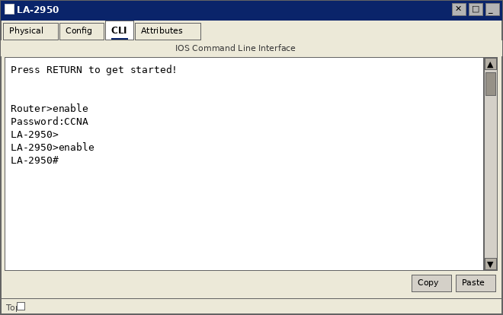

18.2 – Lab Exercise 1: Introduction to Switch
A basic exercise to get familiar with the different commands related to a Cisco switch.
Objective:
Connect to the switch, verify IOS version, inspect interfaces, and display the running configuration.
Step-by-Step Instructions:
- Connect to switch LA-2950 and confirm the user mode prompt appears.
- Enter privileged mode using the enable command (Password: CCNA).
- Issue the show version command to display IOS version and hardware details.
- Issue the show interfaces command to display all interface statistics.
- Issue the show running-config command to display the active configuration.

Commands Executed:
LA-2950>enable
Password:CCNA
LA-2950#show version
LA-2950#show interfaces
LA-2950#show running-config

Figure: show version – displays IOS version, hardware, uptime, and memory
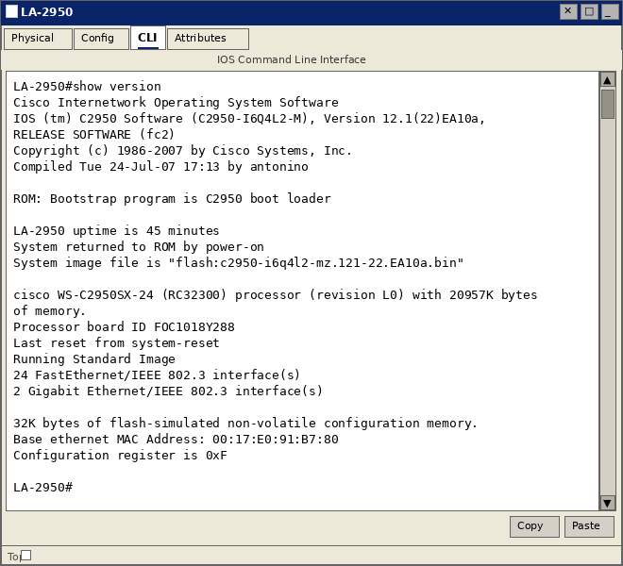

Figure: show running-config – displays the active running configuration
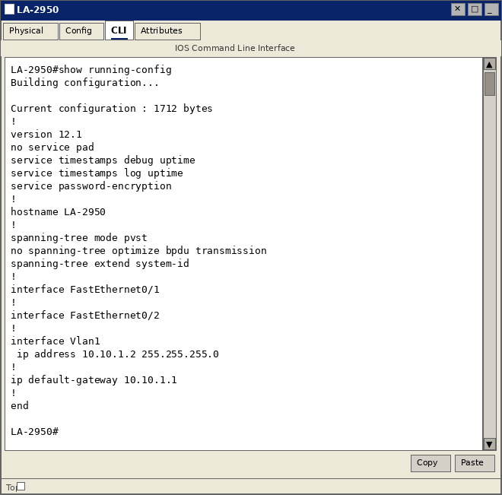

Figure: show interfaces – displays statistics and status for all switch interfaces
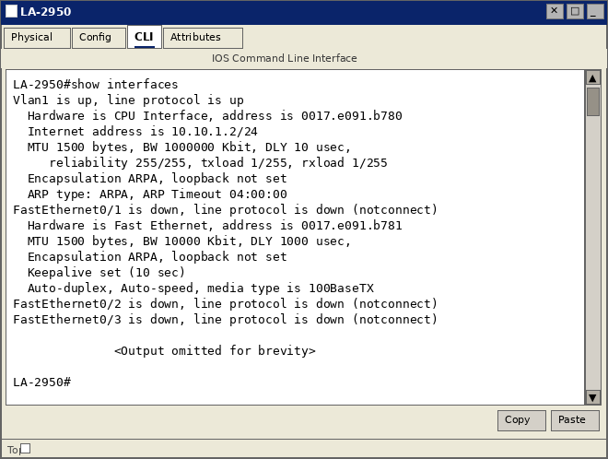

18.3 – Lab Exercise 2: Switch Console Password Assignment
This exercise explains configuring a console password. The console port provides direct physical access to the switch and must be secured.
Objective:
Set the console password to "consolepass" and enable login requirement on the console line.
Step-by-Step Instructions:
- Enter privileged EXEC mode using enable.
- Enter global configuration mode using configure terminal.
- Navigate to line console 0 configuration using line console 0.
- Set the console password: password consolepass
- Enable password checking at login using the login command.
- Exit back to privileged mode and verify using show running-config.

Commands Executed:
LA-2950>enable
LA-2950#configure terminal
LA-2950(config)#line console 0
LA-2950(config-line)#password consolepass
LA-2950(config-line)#login
LA-2950(config-line)#exit
LA-2950(config)#exit
LA-2950#show running-config

Figure: Console password configured – verified in running-config
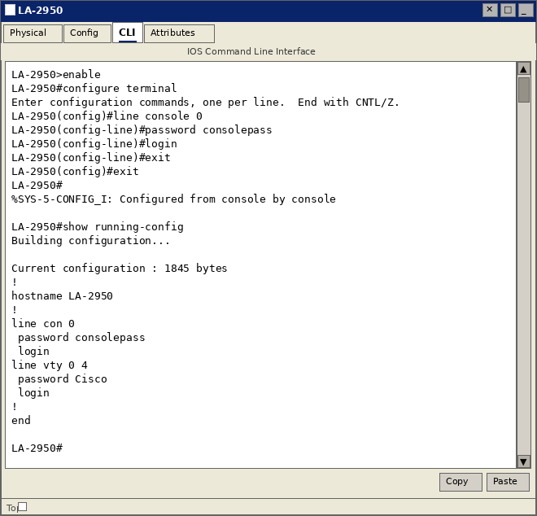
NOTE: The login command is mandatory. Without it, the password is set but NOT enforced — anyone can connect to the console without a password.

18.4 – Lab Exercise 3: Switch VTY Password Assignment
VTY (Virtual Teletype) lines enable remote Telnet/SSH access to the switch. Configuring a VTY password secures all remote management sessions.
Objective:
Set the VTY password to "vtypass" on lines 0–15 and enable login.
Step-by-Step Instructions:
- Enter global configuration mode.
- Enter VTY line configuration for all 16 lines: line vty 0 15
- Set the VTY password: password vtypass
- Enable password enforcement: login
- Exit and verify with show running-config.

Commands Executed:
LA-2950>enable
LA-2950#configure terminal
LA-2950(config)#line vty 0 15
LA-2950(config-line)#password vtypass
LA-2950(config-line)#login
LA-2950(config-line)#exit
LA-2950(config)#exit
LA-2950#show running-config

Figure: VTY password assigned – all 16 VTY lines secured with "vtypass"
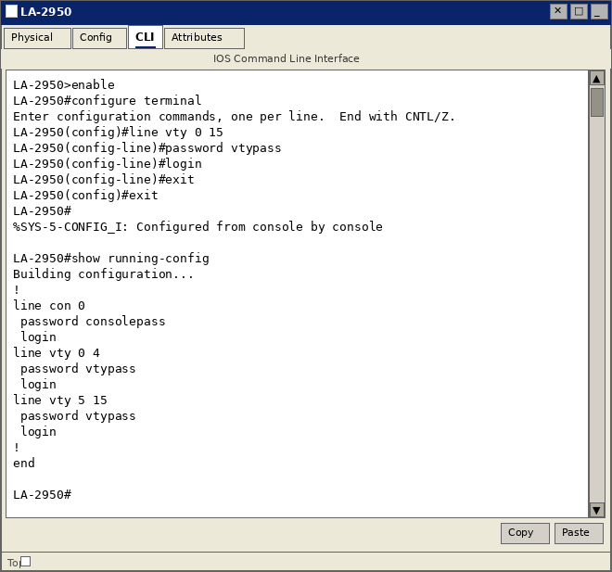

18.5 – Lab Exercise 4: Switch Setting Privileged Password
The enable secret command sets an encrypted (MD5-hashed) privileged mode password. This is more secure than enable password because the hash cannot be reversed.
Objective:
Configure enable secret "enabpass" and verify it appears encrypted in the running configuration.
Step-by-Step Instructions:
- Enter global configuration mode.
- Set the enable secret password: enable secret enabpass
- Optionally set a plain enable password for older devices: enable password CCNA
- Exit and verify with show running-config.
- Observe that enable secret appears as an MD5 hash, while enable password is visible.

Commands Executed:
LA-2950>enable
LA-2950#configure terminal
LA-2950(config)#enable secret enabpass
LA-2950(config)#enable password CCNA
LA-2950(config)#exit
LA-2950#show running-config | include enable

Figure: Enable secret stored as MD5 hash – cannot be read from running-config
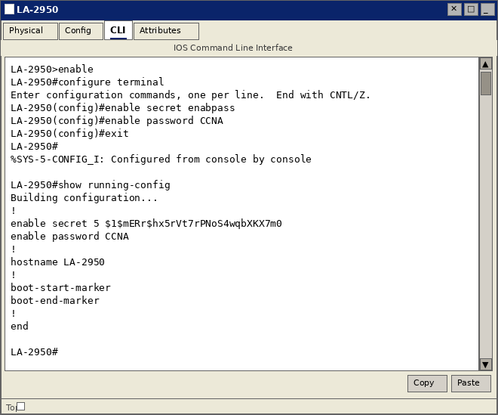
NOTE: When both enable secret and enable password are configured, enable secret always takes precedence. The enable password is ignored.

18.6 – Lab Exercise 5: Enable Fast Ethernet Interface on a Switch
By default, some switch interfaces may be administratively shut down. This exercise enables a FastEthernet interface and configures its duplex and speed settings.
Objective:
Enable FastEthernet 0/1 with auto duplex and auto speed, then verify its operational status.
Step-by-Step Instructions:
- Enter global configuration mode.
- Enter interface configuration for FastEthernet 0/1.
- Set duplex to auto: duplex auto
- Set speed to auto: speed auto
- Enable the interface: no shutdown
- Observe the IOS messages confirming the interface has come up.
- Exit and verify with show interfaces fastethernet 0/1.

Commands Executed:
LA-2950>enable
LA-2950#configure terminal
LA-2950(config)#interface fastethernet 0/1
LA-2950(config-if)#duplex auto
LA-2950(config-if)#speed auto
LA-2950(config-if)#no shutdown
LA-2950(config-if)#exit
LA-2950#show interfaces fastethernet 0/1

Figure: FastEthernet 0/1 enabled – "up, line protocol is up" confirmed
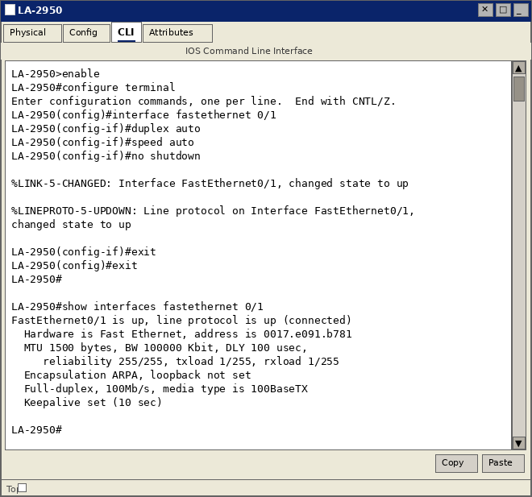

18.7 – Lab Exercise 6: Initial Switch Configuration
Performing a complete initial switch configuration is a standard network engineering task. This exercise combines hostname, password, management IP, and default gateway configuration.
Objective:
Configure the switch from factory defaults: set hostname, passwords, management VLAN interface, default gateway, and save configuration.
Step-by-Step Instructions:
- Enter global configuration mode.
- Set hostname: hostname LA-2950
- Set enable secret password: enable secret CCNA
- Configure console password (password: consolepass) with login.
- Configure VTY password (password: vtypass) on lines 0–15 with login.
- Configure VLAN 1 interface with IP 10.10.1.2 /24 and enable it (no shutdown).
- Set default gateway: ip default-gateway 10.10.1.1
- Save configuration: copy running-config startup-config

Commands Executed:
Switch>enable
Switch#configure terminal
Switch(config)#hostname LA-2950
LA-2950(config)#enable secret CCNA
LA-2950(config)#line console 0
LA-2950(config-line)#password consolepass
LA-2950(config-line)#login
LA-2950(config-line)#exit
LA-2950(config)#line vty 0 15
LA-2950(config-line)#password vtypass
LA-2950(config-line)#login
LA-2950(config-line)#exit
LA-2950(config)#interface vlan 1
LA-2950(config-if)#ip address 10.10.1.2 255.255.255.0
LA-2950(config-if)#no shutdown
LA-2950(config-if)#exit
LA-2950(config)#ip default-gateway 10.10.1.1
LA-2950(config)#exit
LA-2950#copy running-config startup-config

Figure: Complete initial switch configuration with all settings applied
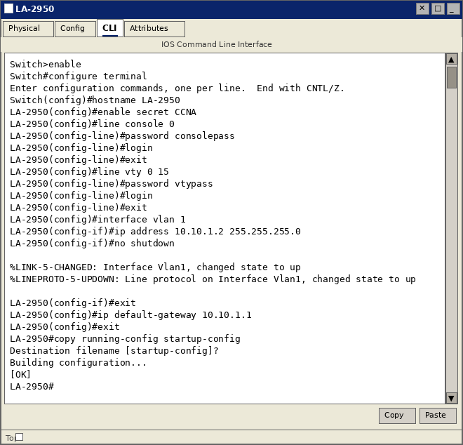

18.8 – Lab Exercise 7: Basic Switch Interface Configuration
Configuring switch interfaces with descriptions and specific duplex/speed settings ensures optimal performance and simplifies troubleshooting.
Objective:
Configure FastEthernet 0/1 with a description, full duplex, 100 Mbps speed, and verify interface status.
Step-by-Step Instructions:
- Enter interface configuration for FastEthernet 0/1.
- Add a description: description Connected to Workstation WS1
- Set duplex to full: duplex full
- Set speed to 100 Mbps: speed 100
- Enable the interface: no shutdown
- Verify with show interface status.

Commands Executed:
LA-2950>enable
LA-2950#configure terminal
LA-2950(config)#interface fastethernet 0/1
LA-2950(config-if)#description Connected to Workstation WS1
LA-2950(config-if)#duplex full
LA-2950(config-if)#speed 100
LA-2950(config-if)#no shutdown
LA-2950(config-if)#exit
LA-2950#show interface status

Figure: Interface status table showing Fa0/1 connected with full duplex, 100 Mbps
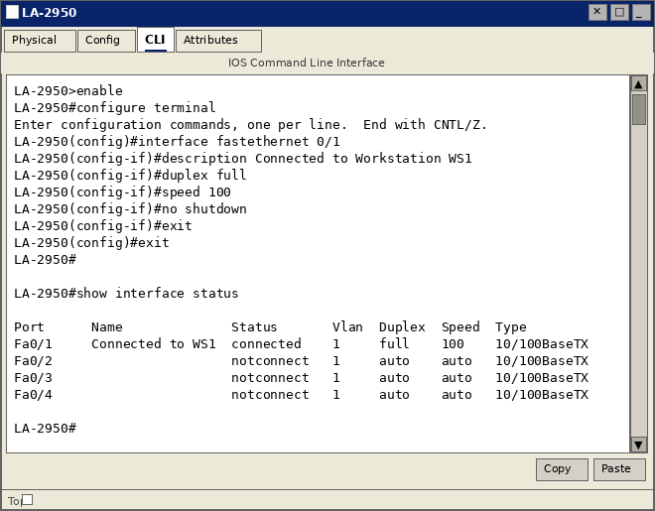

18.9 – Lab Exercise 8: Catalyst 2960S Switch Configuration (SSH)
SSH (Secure Shell) provides encrypted remote management, replacing insecure Telnet. Configuring SSH requires a domain name, RSA key pair, and SSH version 2 setting.
Objective:
Enable SSH version 2 on the Catalyst switch with RSA 1024-bit keys and restrict VTY access to SSH only.
Step-by-Step Instructions:
- Set the domain name: ip domain-name cisco.com
- Generate RSA keys with 1024-bit modulus: crypto key generate rsa modulus 1024
- Enable SSH version 2: ip ssh version 2
- Create a local user account with privilege level 15.
- Configure VTY lines to accept only SSH: transport input ssh
- Set VTY login to use local user database: login local
- Verify SSH status with show ip ssh.

Commands Executed:
LA-2950>enable
LA-2950#configure terminal
LA-2950(config)#ip domain-name cisco.com
LA-2950(config)#crypto key generate rsa modulus 1024
LA-2950(config)#ip ssh version 2
LA-2950(config)#ip ssh authentication-retries 3
LA-2950(config)#username admin privilege 15 secret adminpass
LA-2950(config)#line vty 0 15
LA-2950(config-line)#transport input ssh
LA-2950(config-line)#login local
LA-2950(config-line)#exit
LA-2950#show ip ssh

Figure: SSH version 2 enabled and verified on LA-2950
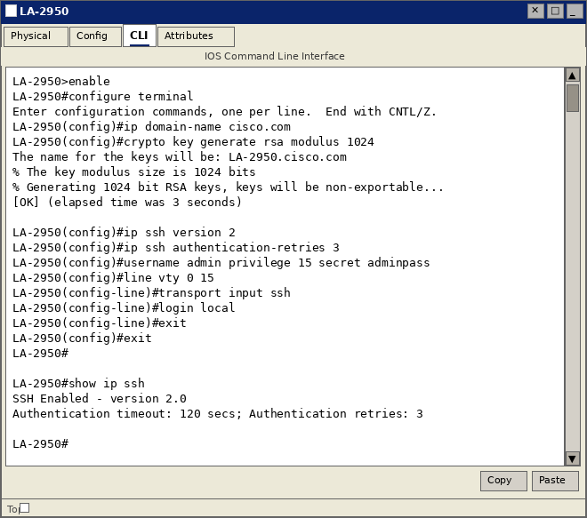
NOTE: The RSA keys must be generated before SSH can be activated. The domain name is required as it forms part of the RSA key identifier (hostname.domainname).

LAB 19: EXERCISES ON SPANNING TREE PROTOCOL (STP)
Spanning Tree Protocol (STP – IEEE 802.1D) prevents Layer 2 switching loops by placing redundant switch ports into a blocking state. STP elects a Root Bridge and builds a loop-free logical topology. All exercises use switch LA-2950.

19.1 – Lab Exercise 1: Enabling STP
STP is enabled by default on all Cisco Catalyst switches. This exercise demonstrates how to explicitly enable or disable STP on a specific VLAN.
Objective:
Enable STP on VLAN 1, then disable it, then re-enable it. Verify the STP state using show spanning-tree.
Step-by-Step Instructions:
- Enter global configuration mode.
- Enable STP on VLAN 1: spanning-tree vlan 1
- Disable STP on VLAN 1: no spanning-tree vlan 1
- Re-enable STP on VLAN 1: spanning-tree vlan 1
- Exit configuration mode.
- Verify STP state: show spanning-tree vlan 1

Commands Executed:
LA-2950>enable
LA-2950#configure terminal
LA-2950(config)#spanning-tree vlan 1
LA-2950(config)#no spanning-tree vlan 1
LA-2950(config)#spanning-tree vlan 1
LA-2950(config)#exit
LA-2950#show spanning-tree vlan 1

Figure: STP enabled on VLAN 1 – bridge is root, ports in forwarding state (FWD)
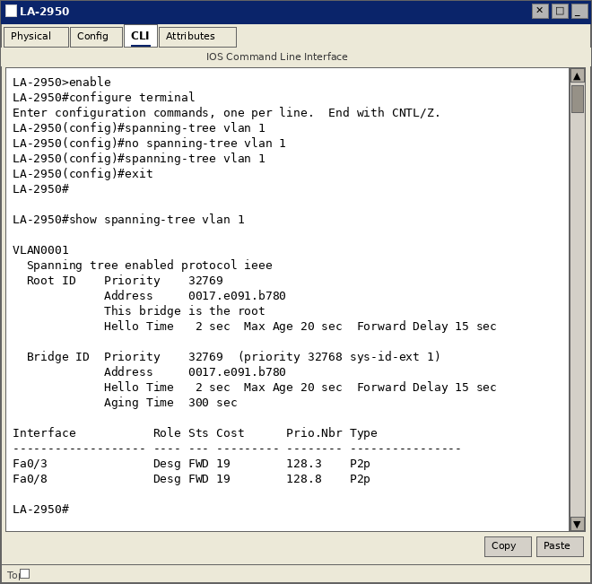
NOTE: Disabling STP on active VLANs with redundant links will cause broadcast storms and network loops. Only disable STP on ports configured with PortFast + BPDU Guard.

19.2 – Lab Exercise 2: Configuring Root Switch
The Root Bridge is the reference point for all STP path calculations. The switch with the lowest Bridge Priority becomes the Root Bridge. If priorities are equal, the switch with the lowest MAC address wins.
Objective:
Configure LA-2950 as the root bridge for VLAN 1 using the spanning-tree root primary command.
Step-by-Step Instructions:
- Enter global configuration mode.
- Set the switch as root bridge for VLAN 1: spanning-tree vlan 1 root primary
- IOS automatically sets the priority to 24576 (lower than default 32768).
- Exit configuration mode.
- Verify with: show spanning-tree vlan 1
- Confirm the output shows "This bridge is the root".

Commands Executed:
LA-2950>enable
LA-2950#configure terminal
LA-2950(config)#spanning-tree vlan 1 root primary
LA-2950(config)#exit
LA-2950#show spanning-tree vlan 1

Figure: LA-2950 confirmed as Root Bridge – priority 24577, all ports Designated/FWD
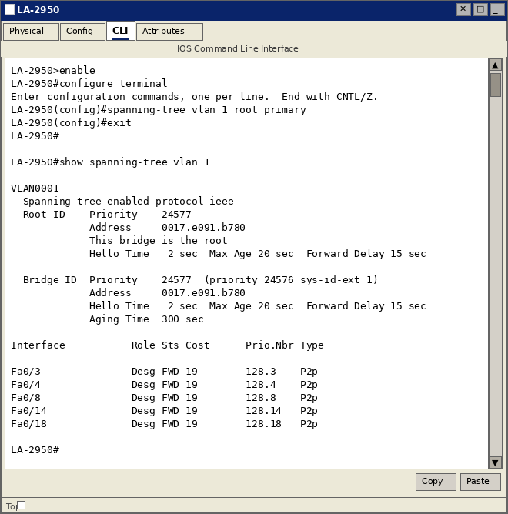

19.3 – Lab Exercise 3: Configuring Port Priority
Port priority influences which port a downstream switch will select as its Root Port when there are equal-cost paths. Lower port priority value = higher priority (more likely to be selected).
Objective:
Change the STP port priority on FastEthernet 0/1 from the default 128 to 64.
Step-by-Step Instructions:
- Enter interface configuration for FastEthernet 0/1.
- Set port priority to 64 for VLAN 1: spanning-tree vlan 1 port-priority 64
- Exit interface and global configuration.
- Verify: show spanning-tree interface fastethernet 0/1
- Observe the Prio.Nbr column shows 64.1 instead of the default 128.1.

Commands Executed:
LA-2950>enable
LA-2950#configure terminal
LA-2950(config)#interface fastethernet 0/1
LA-2950(config-if)#spanning-tree vlan 1 port-priority 64
LA-2950(config-if)#exit
LA-2950(config)#exit
LA-2950#show spanning-tree interface fastethernet 0/1
LA-2950#show spanning-tree vlan 1

Figure: Port priority changed to 64 on Fa0/1 – Prio.Nbr shows 64.1
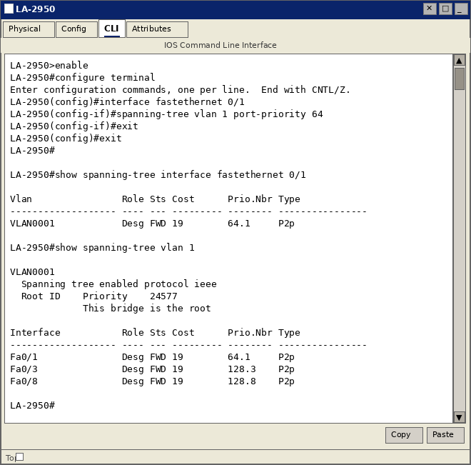

19.4 – Lab Exercise 4: Configuring Switch Priority of a VLAN
The bridge priority determines whether a switch becomes the Root Bridge. Lower priority = higher chance of becoming root. Values must be multiples of 4096 (0–61440), default is 32768.
Objective:
Set the bridge priority for VLAN 1 to 4096, making LA-2950 the most likely root bridge.
Step-by-Step Instructions:
- Enter global configuration mode.
- Set VLAN 1 priority to 4096: spanning-tree vlan 1 priority 4096
- Exit configuration mode.
- Verify: show spanning-tree vlan 1
- Observe the Bridge ID Priority field shows 4097 (4096 + 1 for VLAN sys-id-ext).

Commands Executed:
LA-2950>enable
LA-2950#configure terminal
LA-2950(config)#spanning-tree vlan 1 priority 4096
LA-2950(config)#exit
LA-2950#show spanning-tree vlan 1

Figure: Bridge priority set to 4097 (4096+1) for VLAN 1 – switch is root bridge
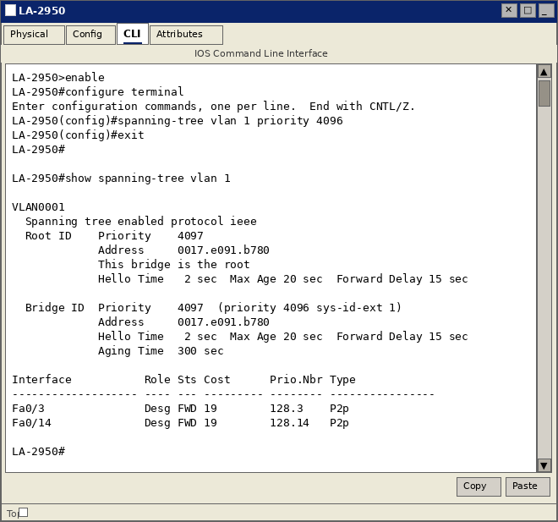
NOTE: Priority must be set in exact multiples of 4096. Entering any other value will produce an error: "% Bridge Priority must be in increments of 4096."

19.5 – Lab Exercise 5: Configuring STP Timers
STP uses three timers to control topology changes. These should only be modified on the Root Bridge, as the timers propagate to all switches via BPDUs.
Timer Reference:
Timer | Default | Valid Range | Set Value
Hello Time | 2 sec | 1–10 sec | 3 sec
Max Age | 20 sec | 6–40 sec | 25 sec
Forward Delay | 15 sec | 4–30 sec | 18 sec

Step-by-Step Instructions:
- Enter global configuration mode.
- Set Hello Time to 3 seconds: spanning-tree vlan 1 hello-time 3
- Set Max Age to 25 seconds: spanning-tree vlan 1 max-age 25
- Set Forward Delay to 18 seconds: spanning-tree vlan 1 forward-time 18
- Exit and verify: show spanning-tree vlan 1

Commands Executed:
LA-2950>enable
LA-2950#configure terminal
LA-2950(config)#spanning-tree vlan 1 hello-time 3
LA-2950(config)#spanning-tree vlan 1 max-age 25
LA-2950(config)#spanning-tree vlan 1 forward-time 18
LA-2950(config)#exit
LA-2950#show spanning-tree vlan 1

Figure: STP timers modified – Hello Time 3s, Max Age 25s, Forward Delay 18s confirmed
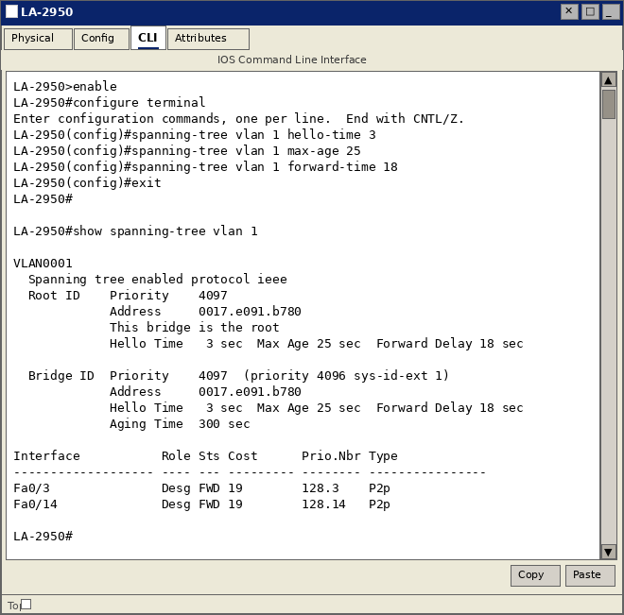

19.6 – Lab Exercise 6: Verifying STP
Multiple show commands are used to verify and troubleshoot STP. This exercise demonstrates a comprehensive verification of STP state across the switch.
Objective:
Use show spanning-tree commands to verify port roles, port states, root bridge identity, and bridge timers.
Step-by-Step Instructions:
- Issue show spanning-tree to view overall STP status for all VLANs.
- Issue show spanning-tree vlan 1 for detailed VLAN 1 STP information.
- Issue show spanning-tree detail for extended interface-level STP details.
- Issue show spanning-tree summary to see which VLANs have STP active.
- Review port roles: Root Port (RP), Designated Port (Desg), Alternate Port (Altn).
- Review port states: FWD (Forwarding), BLK (Blocking), LRN (Learning).

Commands Executed:
LA-2950>enable
LA-2950#show spanning-tree
LA-2950#show spanning-tree vlan 1
LA-2950#show spanning-tree detail
LA-2950#show spanning-tree summary
LA-2950#show spanning-tree interface fastethernet 0/1

Figure: Full STP verification – root bridge status, port roles (Desg), and forwarding states (FWD)
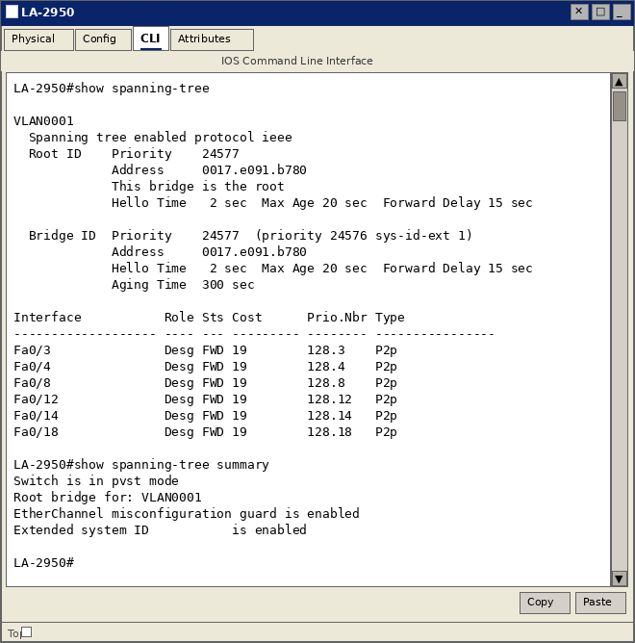

LAB 20: EXERCISES ON SWITCH CONFIGURATION AND VLAN
This lab covers VLAN creation and assignment, port security, trunk configuration, VTP (VLAN Trunking Protocol), troubleshooting, and inter-VLAN routing using the Router-on-a-Stick technique.

20.1 – Lab Exercise 1: Basic Switch IP Configuration
To manage a Cisco switch remotely, it requires an IP address assigned to the management VLAN (typically VLAN 1) and a default gateway to reach devices on other networks.
Objective:
Assign IP address 10.10.1.2/24 to VLAN 1 on LA-2950, set default gateway 10.10.1.1, and verify.
Step-by-Step Instructions:
- Enter global configuration mode.
- Enter VLAN 1 interface configuration: interface vlan 1
- Assign IP address: ip address 10.10.1.2 255.255.255.0
- Enable the VLAN interface: no shutdown
- Exit interface mode and set default gateway: ip default-gateway 10.10.1.1
- Verify with: show running-config and show interface vlan 1

Commands Executed:
LA-2950>enable
LA-2950#configure terminal
LA-2950(config)#interface vlan 1
LA-2950(config-if)#ip address 10.10.1.2 255.255.255.0
LA-2950(config-if)#no shutdown
LA-2950(config-if)#exit
LA-2950(config)#ip default-gateway 10.10.1.1
LA-2950(config)#end
LA-2950#show running-config
LA-2950#show interface vlan 1

Figure: VLAN 1 IP 10.10.1.2/24 configured and up – default gateway 10.10.1.1 set
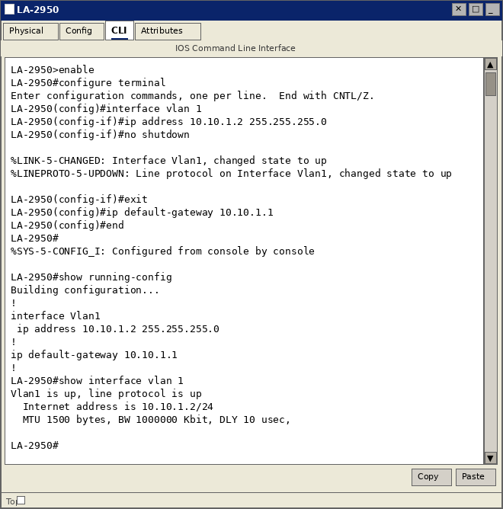

20.2 – Lab Exercise 2: Configure and Verify Port Security on Switch
Port security restricts access to a switch port by limiting the number of MAC addresses allowed and specifying what action to take on a violation.
Port Security Violation Modes:
Mode | Action on Violation
Shutdown (default) | Port enters err-disabled state; syslog and SNMP trap sent; manual recovery required
Restrict | Violating frames dropped; syslog and SNMP trap generated; port stays up; violation counter incremented
Protect | Violating frames silently dropped; no notification; port stays up; violation counter NOT incremented

Step-by-Step Instructions:
- Enter configuration mode and navigate to interface FastEthernet 0/1.
- Set port to access mode: switchport mode access
- Enable port security: switchport port-security
- Set max MAC addresses to 5: switchport port-security maximum 5
- Set violation mode to shutdown: switchport port-security violation shutdown
- Configure static MAC address: switchport port-security mac-address 2222.3333.4444
- Enable sticky MAC learning: switchport port-security mac-address sticky
- Verify: show port-security and show port-security interface fastethernet 0/1

Commands Executed:
NY-2960>enable
Password:Cisco
NY-2960#configure terminal
NY-2960(config)#interface fastethernet 0/1
NY-2960(config-if)#switchport mode access
NY-2960(config-if)#switchport port-security
NY-2960(config-if)#switchport port-security maximum 5
NY-2960(config-if)#switchport port-security violation shutdown
NY-2960(config-if)#switchport port-security mac-address 2222.3333.4444
NY-2960(config-if)#switchport port-security mac-address sticky
NY-2960(config-if)#end
NY-2960#show port-security
NY-2960#show port-security interface fastethernet 0/1

Figure: Port security summary – Fa0/1 with MaxSecureAddr=5, violation action=Shutdown
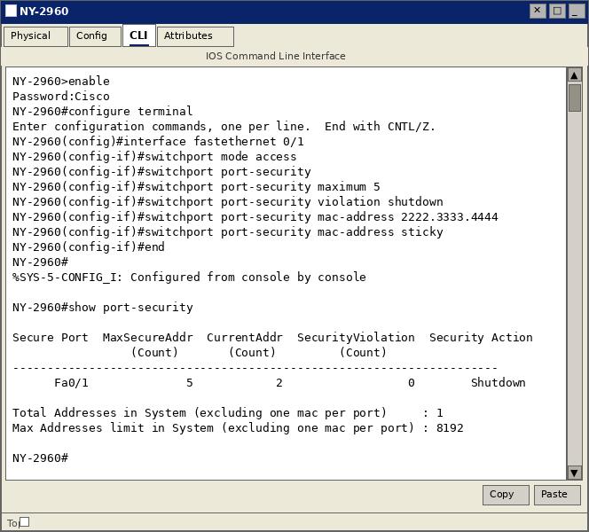

Figure: Port security interface detail – enabled, secure-up, 5 max MACs, sticky learning active
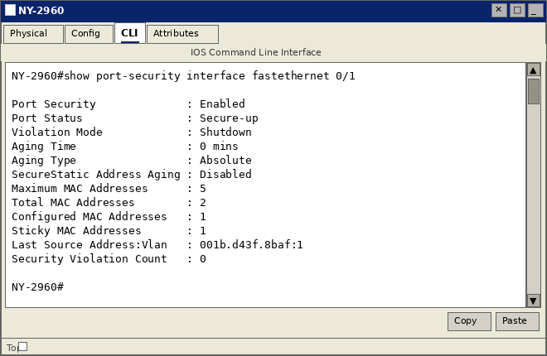
NOTE: Port security does NOT work on trunk ports, EtherChannel ports, or SPAN destination ports. Always set switchport mode access before enabling port security.

20.3 – Lab Exercise 3: Troubleshooting a Switch
Systematic troubleshooting uses a combination of show commands to identify and resolve switch problems including interface issues, port security violations, and connectivity failures.
Step-by-Step Troubleshooting Procedure:
- Issue show interfaces status to see all ports and their operational status at once.
- Look for err-disabled ports (indicate port security or other violations).
- Check show mac address-table to verify MAC address learning on ports.
- Use show cdp neighbors to verify physical connectivity to adjacent devices.
- Check show log for any system error messages related to interfaces.
- For err-disabled recovery: issue shutdown then no shutdown on the affected interface.

Troubleshooting Commands:
LA-2950>enable
LA-2950#show interfaces status
LA-2950#show mac address-table
LA-2950#show mac address-table interface fastethernet 0/1
LA-2950#show arp
LA-2950#show cdp neighbors
LA-2950#show log

Figure: Switch troubleshooting – interface status table with err-disabled port visible
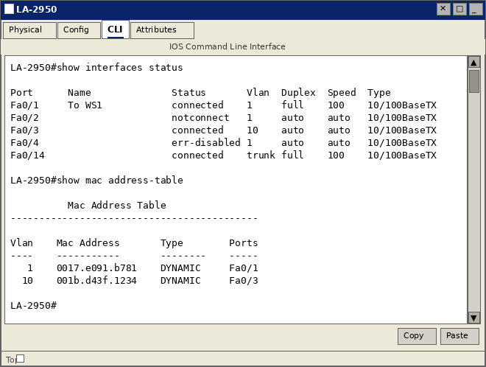

20.4 – Lab Exercise 4: Switch Trunking Configuration
Trunk links carry traffic for multiple VLANs between switches using IEEE 802.1Q encapsulation. Each frame is tagged with a 4-byte VLAN identifier. The native VLAN is sent untagged.
Objective:
Configure FastEthernet 0/14 as an 802.1Q trunk allowing VLANs 1, 10, 20, and 30.
Step-by-Step Instructions:
- Enter interface configuration for FastEthernet 0/14.
- Set the port to trunk mode: switchport mode trunk
- Specify allowed VLANs: switchport trunk allowed vlan 1,10,20,30
- Set native VLAN: switchport trunk native vlan 1
- Exit and verify: show interfaces trunk

Commands Executed:
LA-2950>enable
LA-2950#configure terminal
LA-2950(config)#interface fastethernet 0/14
LA-2950(config-if)#switchport mode trunk
LA-2950(config-if)#switchport trunk allowed vlan 1,10,20,30
LA-2950(config-if)#switchport trunk native vlan 1
LA-2950(config-if)#exit
LA-2950(config)#exit
LA-2950#show interfaces trunk

Figure: Trunk formed on Fa0/14 – 802.1q encapsulation, VLANs 1,10,20,30 active on trunk
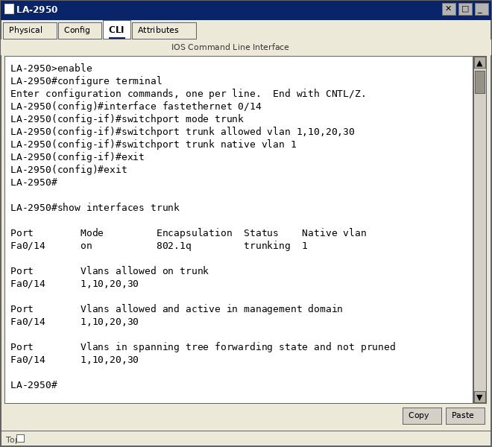

20.5 – Lab Exercise 5: Creating and Deleting VLANs
VLANs logically segment a switch into separate broadcast domains. Devices in different VLANs cannot communicate without a Layer 3 device (router or Layer 3 switch).
Objective:
Create VLANs 10 (SALES) and 20 (ENGINEERING), assign ports to them, and delete VLAN 30. Verify with show vlan brief.
Step-by-Step Instructions:
- Enter VLAN configuration: vlan 10, then name SALES
- Create VLAN 20: vlan 20, then name ENGINEERING
- Assign FastEthernet 0/3 to VLAN 10 using switchport access vlan 10.
- Assign FastEthernet 0/4 to VLAN 20 using switchport access vlan 20.
- Delete VLAN 30 (if it exists): no vlan 30
- Verify: show vlan brief

Commands Executed:
LA-2950>enable
LA-2950#configure terminal
LA-2950(config)#vlan 10
LA-2950(config-vlan)#name SALES
LA-2950(config-vlan)#exit
LA-2950(config)#vlan 20
LA-2950(config-vlan)#name ENGINEERING
LA-2950(config-vlan)#exit
LA-2950(config)#no vlan 30
LA-2950(config)#interface fastethernet 0/3
LA-2950(config-if)#switchport mode access
LA-2950(config-if)#switchport access vlan 10
LA-2950(config-if)#exit
LA-2950(config)#exit
LA-2950#show vlan brief

Figure: show vlan brief – VLANs 10 (SALES) and 20 (ENGINEERING) created with assigned ports
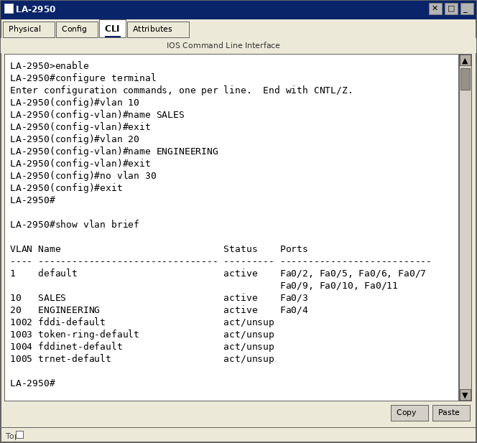

20.6 – Lab Exercise 6: Configuring VTP on a Switch (Server Mode)
VLAN Trunking Protocol (VTP) propagates VLAN configuration from a VTP Server to VTP Clients automatically over trunk links, eliminating the need to configure VLANs on every switch.
VTP Modes:
- Server – Creates, modifies, deletes VLANs and advertises to clients. Stores VLANs in NVRAM.
- Client – Receives and forwards VTP advertisements. Cannot create/delete VLANs.
- Transparent – Passes VTP info without using it. Manages its own independent VLAN database.

Step-by-Step Instructions (VTP Server – LA-2950):
- Set VTP domain name: vtp domain CCNA_DOMAIN
- Set VTP mode to server: vtp mode server
- Set VTP password: vtp password cisco123
- Enable VTP version 2: vtp version 2
- Verify: show vtp status

Commands Executed:
LA-2950>enable
LA-2950#configure terminal
LA-2950(config)#vtp domain CCNA_DOMAIN
LA-2950(config)#vtp mode server
LA-2950(config)#vtp password cisco123
LA-2950(config)#vtp version 2
LA-2950(config)#exit
LA-2950#show vtp status
LA-2950#show vtp password

Figure: VTP Server configured – domain CCNA_DOMAIN, mode Server, version 2, config revision 3
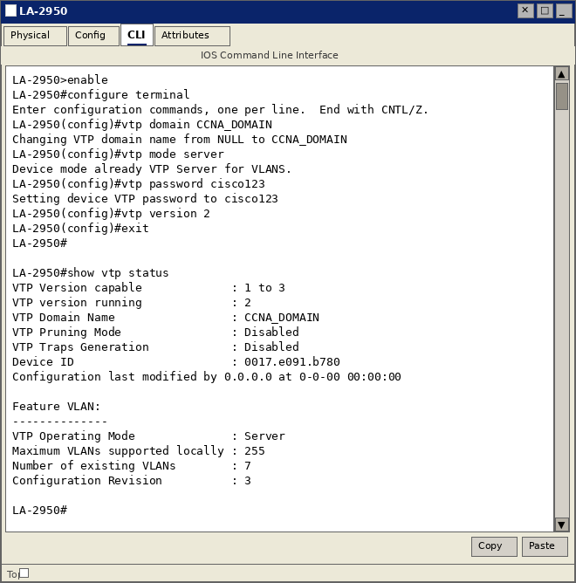

20.7 – Lab Exercise 7: Configuring VTP with a VTP Client
A VTP Client switch receives VLAN configuration from the VTP Server automatically. The domain name and password must exactly match the server for VTP advertisements to be accepted.
Objective:
Configure NY-2960 as a VTP Client with domain CCNA_DOMAIN and password cisco123, then verify VLAN propagation.
Step-by-Step Instructions:
- On NY-2960, set the VTP domain: vtp domain CCNA_DOMAIN
- Set VTP mode to client: vtp mode client
- Set the VTP password: vtp password cisco123
- Ensure the trunk link to LA-2950 is active.
- Verify VTP status: show vtp status
- Verify VLANs propagated: show vlan brief

Commands Executed:
NY-2960>enable
NY-2960#configure terminal
NY-2960(config)#vtp domain CCNA_DOMAIN
NY-2960(config)#vtp mode client
NY-2960(config)#vtp password cisco123
NY-2960(config)#exit
NY-2960#show vtp status
NY-2960#show vlan brief

Figure: VTP Client NY-2960 – VLANs 10 (SALES) and 20 (ENGINEERING) propagated from server
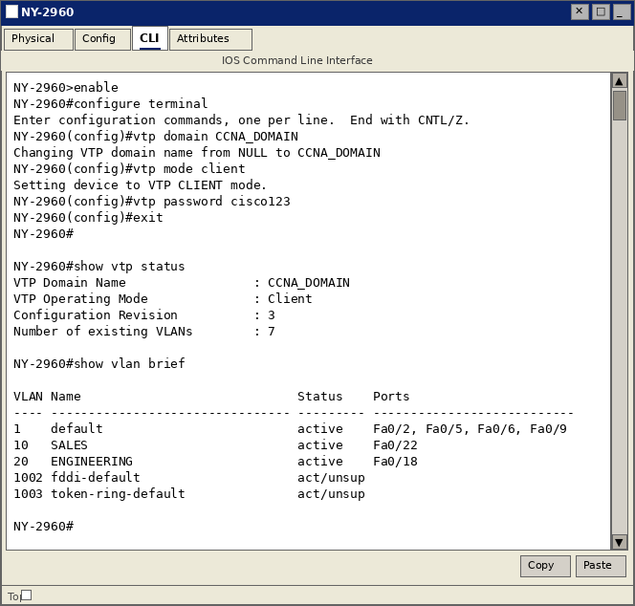
NOTE: VTP domain names are case-sensitive. "CCNA_DOMAIN" and "ccna_domain" are treated as different domain names.

20.8 – Lab Exercise 8: Troubleshooting Lab with Non-Matching Domains
A common VTP issue is mismatched domain names between server and client, causing VLANs to not propagate. This exercise demonstrates the symptom and resolution.
Scenario:
NY-2960 is configured with domain WRONG_DOMAIN. VLANs 10 and 20 from the server do NOT appear. After correcting the domain to CCNA_DOMAIN, the VLANs propagate successfully.
Step-by-Step Instructions:
- Simulate the issue: set NY-2960 VTP domain to WRONG_DOMAIN.
- Observe that VLANs 10 and 20 are not present on NY-2960 (show vlan brief).
- Identify the mismatch using show vtp status.
- Fix: change domain to CCNA_DOMAIN on NY-2960.
- Verify VLANs 10 and 20 now appear after the domain is corrected.

Commands Executed:
-- Simulating mismatch --
NY-2960(config)#vtp domain WRONG_DOMAIN
NY-2960#show vlan brief <- VLANs 10,20 missing!
-- Correcting domain --
NY-2960(config)#vtp domain CCNA_DOMAIN
NY-2960#show vtp status
NY-2960#show vlan brief <- VLANs 10,20 now present

Figure: Domain mismatch causing VLAN loss → corrected to CCNA_DOMAIN → VLANs restored
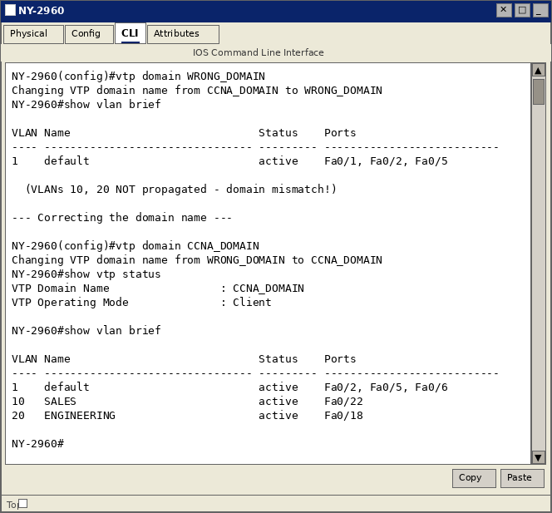

20.9 – Lab Exercise 9: Troubleshooting Lab with Trunk Functionality
Trunk link issues prevent VLANs from propagating between switches. This exercise identifies a common trunk misconfiguration and demonstrates the resolution.
Scenario:
The trunk link on Fa0/14 is not operational because the port mode is set to "dynamic desirable" instead of trunk. After correcting this, the trunk forms and VLANs propagate.
Step-by-Step Instructions:
- Check trunk status: show interfaces fastethernet 0/14 switchport
- Observe "Operational Mode: static access" — trunk is NOT formed.
- Enter interface configuration for Fa0/14.
- Set mode to trunk: switchport mode trunk
- Set native VLAN: switchport trunk native vlan 1
- Allow all VLANs: switchport trunk allowed vlan all
- Verify trunk is now operational: show interfaces trunk

Commands Executed:
LA-2950#show interfaces fastethernet 0/14 switchport
-- Identifies trunk not formed --
LA-2950(config)#interface fastethernet 0/14
LA-2950(config-if)#switchport mode trunk
LA-2950(config-if)#switchport trunk native vlan 1
LA-2950(config-if)#switchport trunk allowed vlan all
LA-2950(config-if)#exit
LA-2950#show interfaces trunk

Figure: Trunk issue identified and resolved – Fa0/14 now shows trunking status
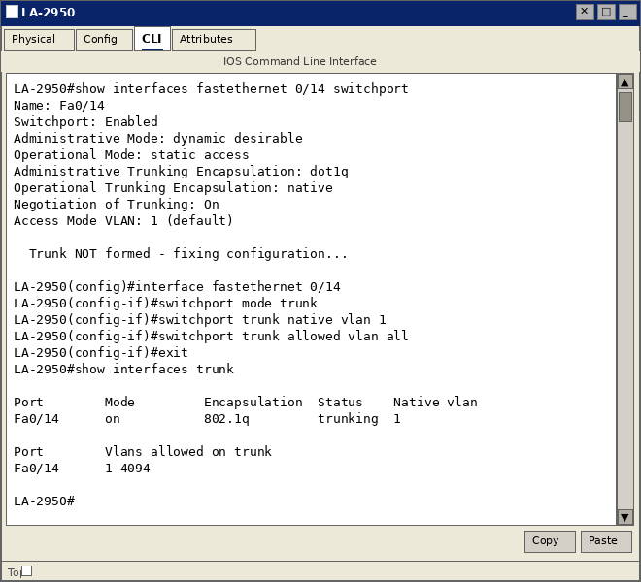

20.10 – Lab Exercise 10: VLANs Scenario
A practical scenario involving two switches with multiple VLANs. Workstations are assigned to VLANs based on department, and inter-switch connectivity is provided via a trunk.
Network Setup:
- LA-2950: Fa0/3 → VLAN 10 (SALES) | Fa0/8 → VLAN 20 (ENGINEERING) | Fa0/14 → Trunk
- NY-2960: Fa0/22 → VLAN 10 | Fa0/18 → VLAN 20 | Fa0/14 → Trunk

Step-by-Step Instructions:
- Create VLANs 10 (SALES) and 20 (ENGINEERING) on LA-2950.
- Assign Fa0/3 to VLAN 10 and Fa0/8 to VLAN 20 (access mode).
- Configure Fa0/14 as trunk link to NY-2960.
- Verify VLAN assignment with show vlan brief.

Commands Executed:
LA-2950>enable
LA-2950#configure terminal
LA-2950(config)#vlan 10
LA-2950(config-vlan)#name SALES
LA-2950(config-vlan)#exit
LA-2950(config)#vlan 20
LA-2950(config-vlan)#name ENGINEERING
LA-2950(config-vlan)#exit
LA-2950(config)#interface fastethernet 0/3
LA-2950(config-if)#switchport mode access
LA-2950(config-if)#switchport access vlan 10
LA-2950(config-if)#exit
LA-2950(config)#interface fastethernet 0/8
LA-2950(config-if)#switchport mode access
LA-2950(config-if)#switchport access vlan 20
LA-2950(config-if)#exit
LA-2950(config)#interface fastethernet 0/14
LA-2950(config-if)#switchport mode trunk
LA-2950(config-if)#exit
LA-2950(config)#exit
LA-2950#show vlan brief

Figure: VLAN scenario complete – VLAN 10/SALES on Fa0/3, VLAN 20/ENGINEERING on Fa0/8
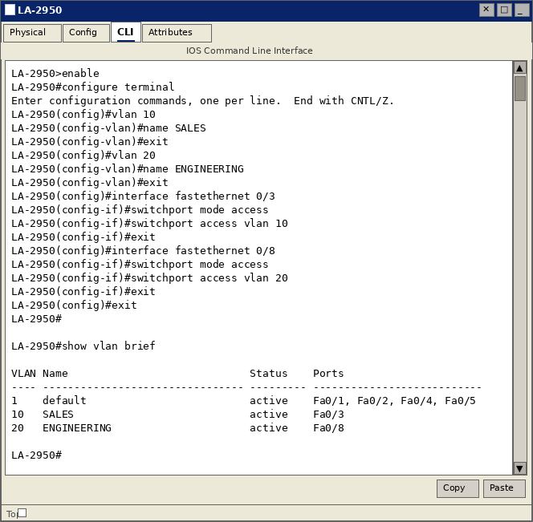

20.11 – Lab Exercise 11: VTP (VLAN Trunking Protocol) Scenario
A complete end-to-end VTP scenario: LA-2950 acts as VTP Server, NY-2960 acts as VTP Client. VLANs created on the server are automatically propagated to the client through the trunk link.
Step-by-Step Instructions:
- On LA-2950: configure VTP domain CCNA, mode server, password cisco.
- Create VLANs 10 (SALES) and 20 (ENGINEERING) on LA-2950.
- On NY-2960: configure VTP domain CCNA, mode client, password cisco.
- Ensure trunk link is active between both switches.
- Verify on NY-2960 that VLANs 10 and 20 appear automatically.

Commands Executed:
-- On LA-2950 (VTP Server) --
LA-2950(config)#vtp domain CCNA
LA-2950(config)#vtp mode server
LA-2950(config)#vtp password cisco
LA-2950(config)#vlan 10
LA-2950(config-vlan)#name SALES
LA-2950(config-vlan)#exit
LA-2950(config)#vlan 20
LA-2950(config-vlan)#name ENGINEERING
-- On NY-2960 (VTP Client) --
NY-2960(config)#vtp domain CCNA
NY-2960(config)#vtp mode client
NY-2960(config)#vtp password cisco
NY-2960(config)#exit
NY-2960#show vtp status
NY-2960#show vlan brief

Figure: VTP propagation successful – NY-2960 client learned VLANs 10 and 20 from server
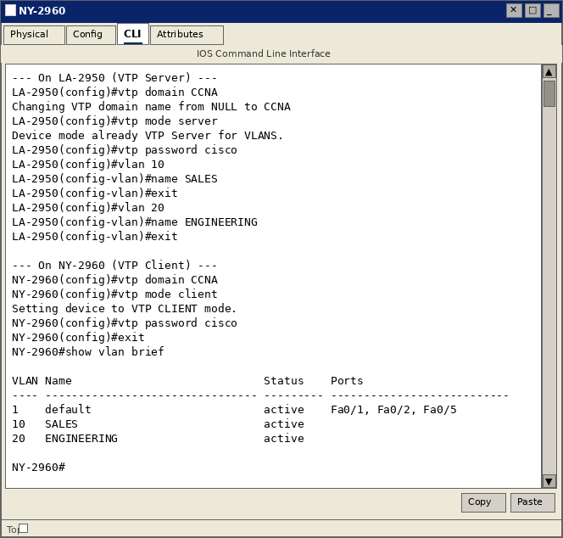

20.12 – Lab Exercise 12: VLANs and Trunking
This exercise integrates VLAN assignment with trunk link configuration, verifying that all VLANs are carried across the trunk and visible on both switches.
Step-by-Step Instructions:
- Verify VLANs 10 and 20 exist on both switches.
- Confirm Fa0/14 is configured as trunk on both LA-2950 and NY-2960.
- Assign access ports on NY-2960 to respective VLANs.
- Verify trunk carries VLANs 1, 10, and 20: show interfaces trunk
- Verify VLAN database: show vlan brief

Commands Executed:
LA-2950#show interfaces trunk
LA-2950#show vlan brief
NY-2960#configure terminal
NY-2960(config)#interface range fastethernet 0/1-5
NY-2960(config-if-range)#switchport mode access
NY-2960(config-if-range)#switchport access vlan 10
NY-2960(config-if-range)#exit
NY-2960#show interfaces trunk
NY-2960#show vlan brief

Figure: Trunk carrying VLANs 1, 10, 20 – all VLANs in forwarding state on Fa0/14
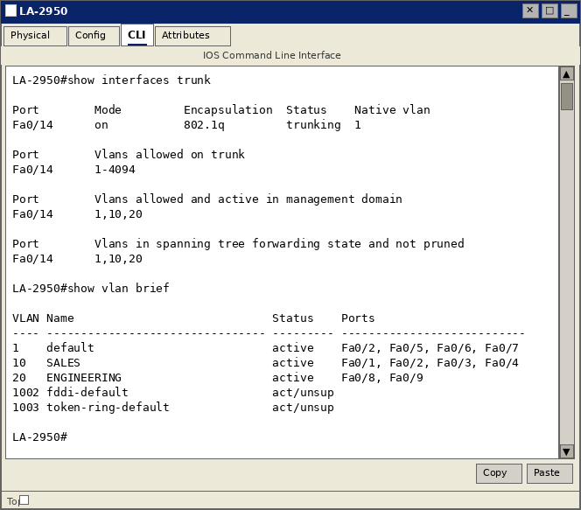

20.13 – Lab Exercise 13: Routing Between VLANs (Router on a Stick)
Devices in different VLANs cannot communicate directly — Layer 3 routing is required. The Router-on-a-Stick method uses a single physical router interface with multiple 802.1Q sub-interfaces to route inter-VLAN traffic.
Network Design:
- VLAN 10 (SALES): 10.10.1.0/24 – Gateway: 10.10.1.1 (Router Fa0/0.10)
- VLAN 20 (ENGINEERING): 10.10.2.0/24 – Gateway: 10.10.2.1 (Router Fa0/0.20)
- Router NY connected to LA-2950 Fa0/1 via trunk link

Step-by-Step Instructions – Router NY:
- Enable the physical interface (no IP address on it): no shutdown on Fa0/0
- Create sub-interface 0/0.10: interface fastethernet 0/0.10
- Set encapsulation: encapsulation dot1q 10
- Assign IP 10.10.1.1/24 as the VLAN 10 gateway.
- Create sub-interface 0/0.20: interface fastethernet 0/0.20
- Set encapsulation: encapsulation dot1q 20
- Assign IP 10.10.2.1/24 as the VLAN 20 gateway.
- Verify routing table: show ip route
- Verify interfaces: show ip interface brief

Step-by-Step Instructions – Switch LA-2950:
- Configure Fa0/1 as trunk toward the router.
- Ensure VLANs 10 and 20 are allowed on the trunk.
- Assign workstation ports to their respective VLANs (access mode).

Commands Executed – Router NY:
NY>enable
NY#configure terminal
NY(config)#interface fastethernet 0/0
NY(config-if)#no shutdown
NY(config-if)#exit
NY(config)#interface fastethernet 0/0.10
NY(config-subif)#encapsulation dot1q 10
NY(config-subif)#ip address 10.10.1.1 255.255.255.0
NY(config-subif)#exit
NY(config)#interface fastethernet 0/0.20
NY(config-subif)#encapsulation dot1q 20
NY(config-subif)#ip address 10.10.2.1 255.255.255.0
NY(config-subif)#exit
NY(config)#exit
NY#show ip route
NY#show ip interface brief

Commands Executed – Switch LA-2950:
LA-2950>enable
LA-2950#configure terminal
LA-2950(config)#interface fastethernet 0/1
LA-2950(config-if)#switchport mode trunk
LA-2950(config-if)#exit
LA-2950(config)#interface fastethernet 0/3
LA-2950(config-if)#switchport mode access
LA-2950(config-if)#switchport access vlan 10
LA-2950(config-if)#exit
LA-2950(config)#interface fastethernet 0/4
LA-2950(config-if)#switchport mode access
LA-2950(config-if)#switchport access vlan 20
LA-2950(config-if)#exit
LA-2950(config)#exit

Figure: Router-on-a-Stick: sub-interfaces up, routing table shows connected routes for both VLANs
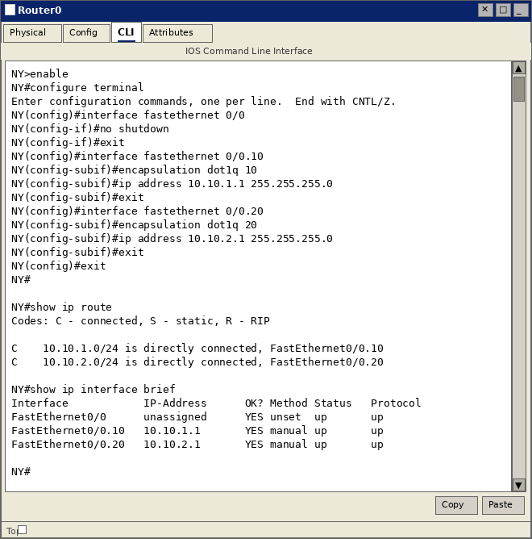
NOTE: The physical interface (Fa0/0) must be "no shutdown" but should have NO IP address. All IP addresses are assigned to sub-interfaces only. The switch trunk port must include both VLANs in the allowed list.

